Zoom Set Up

**For PC/Mac**

**Step 1:**

Navigate to [https://zoom.us/join](https://zoom.us/join%20) or click the blue “Zoom Web Meetings” button on <https://www.plymouthtownship.org/> or via township Facebook post (Pictured below)

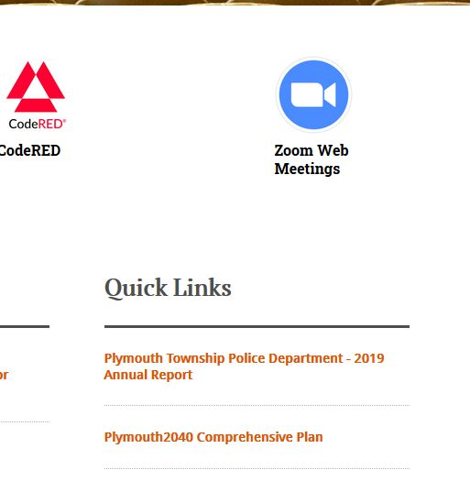

**Step 2:** Enter the meeting ID and password above the blue “Join” button

*Dashes will be added as spaces automatically*

**Step 3** (Image below): The prompt shown below will appear at the top of the webpage. Please click “Open Zoom”.

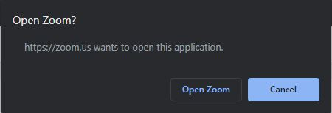

*Please wait while the application loads. This step may take a few moments.*

**Step 4** (Image below): The window shown below will appear. If you are using a PC or Mac, please click “Join with Computer Audio”. Be sure that PC sound is configured appropriately.

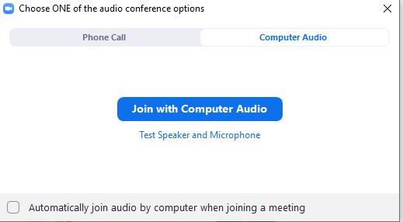

*Optional (Image below): The Zoom Meeting can also be accessed via Phone Call. Click the tab at the top left corner of the prompt labeled “Phone Call”. Start by calling the first number. If it fails to connect, descend the list of numbers. Be sure that the American flag is shown. When prompted by the automated operator, enter the Meeting ID and passcode followed by the # key. Repeat this process for the Participant ID (will be different each time) when prompted. Then click “done” to enter the meeting.*

*Will be different each time*

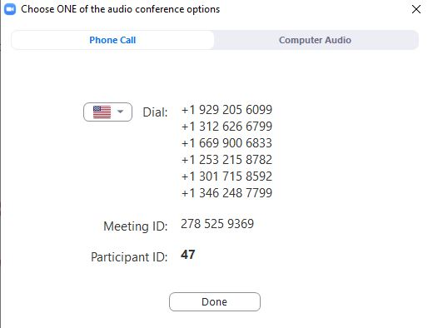

**Step 5:** If you are using a webcam or other external video device, Zoom will ask for permission to use the camera. Confirm with the prompt whether or not you want video displayed. Video can always be turned on and off later as explained in later direction.

**Step 6:** Welcome to the meeting! The center of the window displays other participants in the meeting. If their video is enabled, they will be seen here. If you move your cursor to the bottom of the window, a few options will appear. The only settings that will be of concern can be found below:

Mute: This button enables and disables any audio that is coming from your device. Participants will be muted upon joining the meeting. Participants will be unmuted when audience is asked to comment.



Start Video: This button enables and disables video from appearing in the center of the screen. This button will only be of concern if a webcam or other external video device is being used in the meeting by the user. Use this button the same way as you use the mute button. The host of the meeting will disable a participant’s video if it is deemed inappropriate.



Participants: This button will display a list of all the meeting’s participant’s on the right hand side of the Zoom window. This list will display the name of the participant and an icon identifying which type of media they are using and when they are speaking



Chat: This button will display a chat room for the meeting. This feature will be turned off by an Admin at the beginning of each Zoom meeting.



Raise Hand: Accessed by opening the “Participants” window as shown above. This button can be clicked to signal that a participant has a question. They can use the inverse of the button “Lower Hand” so long as “Raise Hand” is enabled. It is best practice for a participant to lower hand after their question has been resolved. Use this function when the council opens the meeting up for public comment. When you are chosen to speak, please lower hand and the host will unmute you so you may speak.



Tips:

*Assure that webcam and video is configured beforehand*

*When a participant speaks, the border of their attendance “box” in the center of the screen will be highlighted in green.*

*Be on the lookout for participants with their hand raised. Moderator will assist in finding these.*

For iPhone/Android

Step 1: Download the Zoom app from the Apple App Store or the Play Store

Step 2: Launch the application and press “Join a Meeting” at the bottom of the screen

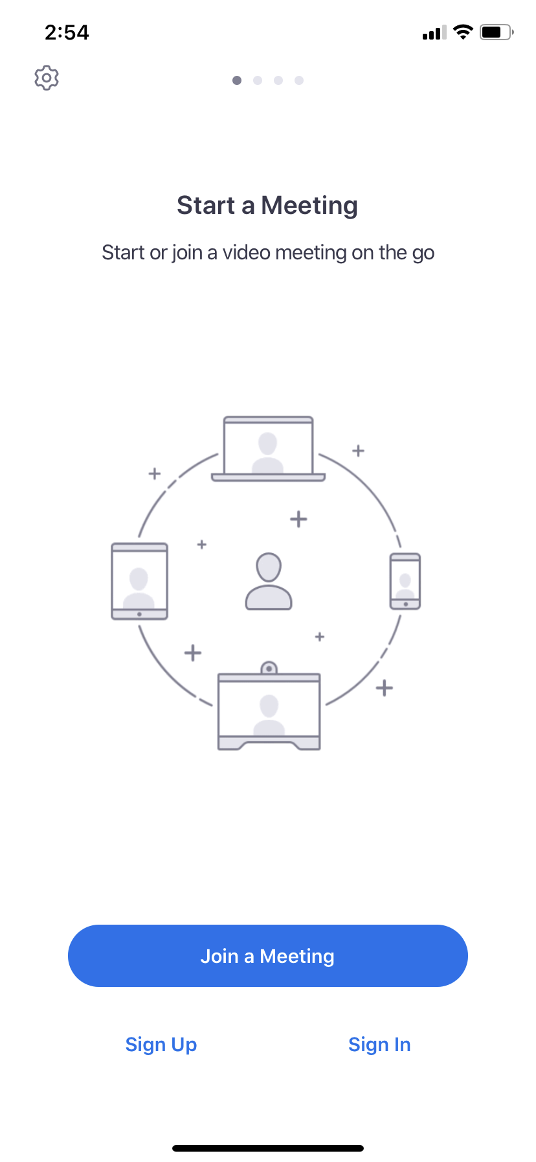

Step 3: Enter the Meeting ID and passcode. You can also change your name on the next line. You can choose to not connect audio and video on the settings at the bottom. Connect to audio if you anticipate participating in audience discussions. Press “Join”

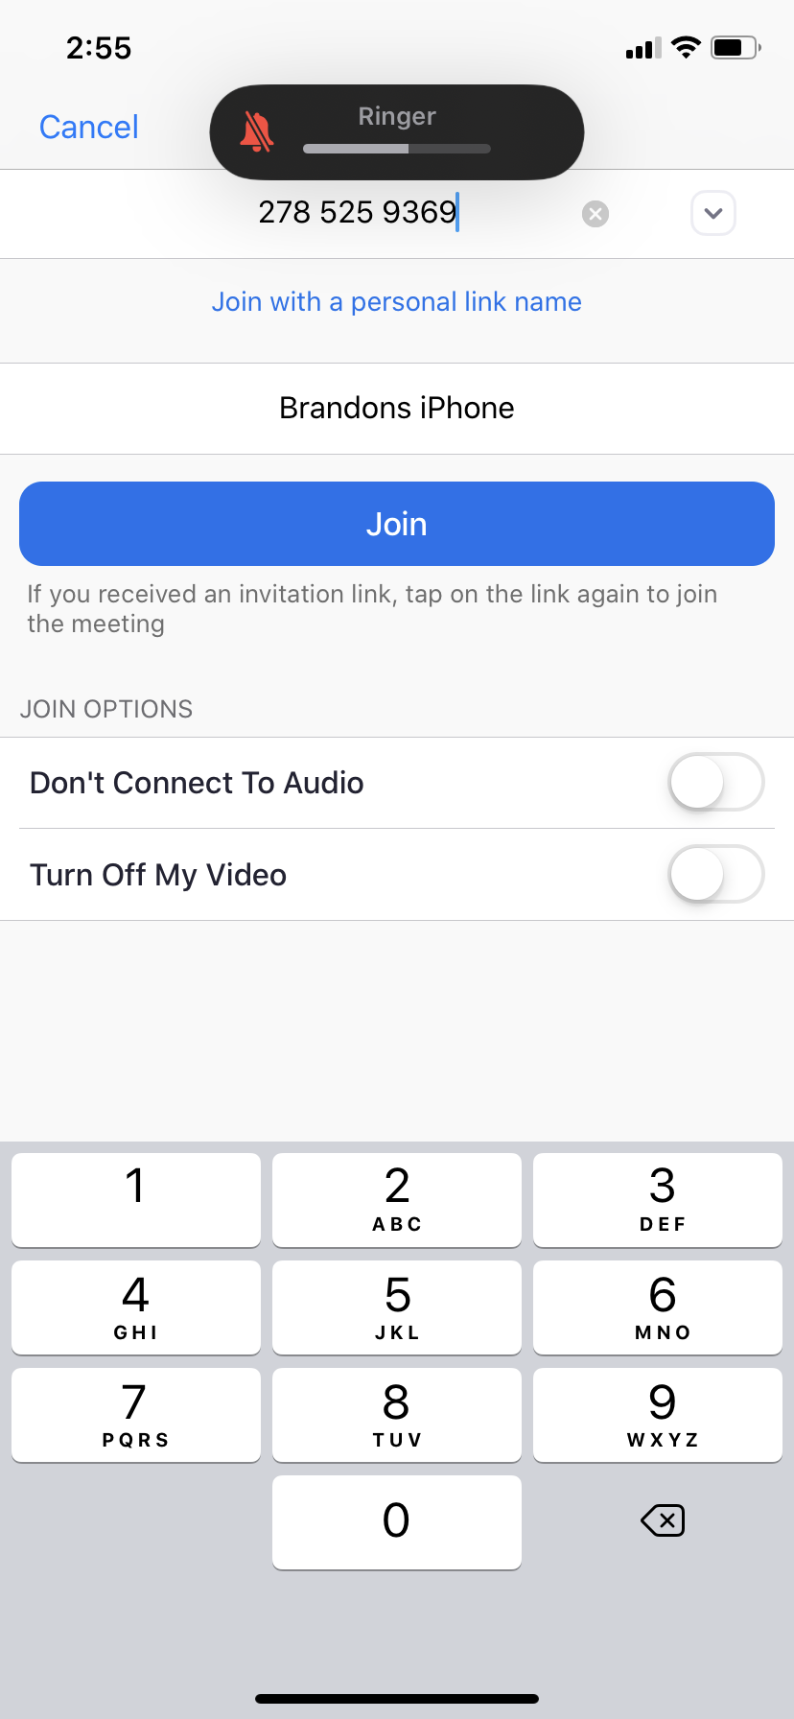

Step 4: Welcome to the meeting! Below are helpful settings when using Zoom:

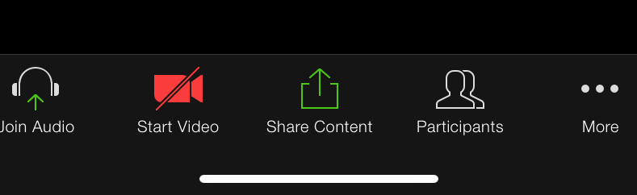

*Refer to the PC/Mac instructions to learn more about these features.*

*Press “More” to access the “Raise Hand” feature. This allows the participant to signal that they have a question. They can use the inverse of the button “Lower Hand” so long as “Raise Hand” is enabled. It is best practice for a participant to lower hand after their question has been resolved.*